Dear Stevensville families,

I am pleased to announce that we are working on many projects at Stevensville Public to enhance student learning and experiences. Not only do we have a new music room with a brand-new class set of ukuleles, we are hitting refresh on our outdoor classroom, gymnasium floor and lighting, and Kindergarten play area! I would like to thank parent council and our Bingo volunteers for their support and fundraising efforts. I would also like to thank our teachers and staff who go above and beyond to create the best learning environment for our students!

We are also looking forward to many events for the remainder of the year including Track and Field, Kindergarten Open House, and our end of the year carnival! We will continue to provide you with updates! We will need lots of support and volunteers to make our carnival a success so please save the date – June 28th! In a few weeks a sign-up sheet will go home with specific volunteer positions.

I would also like to draw your attention to safety in our parking lot and along the road. Remember to drive slowly and avoid parking by the Hill Street crosswalk. This causes an obstruction to the view of those passing and it’s difficult to see our students. I am waiting to hear from the Town of Fort Erie about extra signage or a crossing guard.

As always, we encourage you to reach out by calling the school or emailing Geraldine.Davies@dsbn.org if you have any questions and/or concerns.

We will do our very best to get back to you within 24 hours. Please note that we do not typically respond to inquiries on weekends and holidays.
For ongoing updates, please go to dsbn.org or follow DSBN on social media.
Thank you,
Geraldine (Deana) Davies
Principal SPS

EVENTS/ACTIVITIES IN MAY

SUB DAY
May 25th is Sub Day. Orders are placed through School Cash Online.
Note: Cookies are not guaranteed peanut free, so they are no longer included.

PRACTICE EQAO
Our grade 3 and 6 students will try out the new EQAO format the week of May 9th – 12th.

WATER WALK FOR CLEAN WATER
If you haven’t heard, we had an empowering walk for clean water on Friday! Students clearly learned the valuable lessons that their teachers have led them through over the past several weeks and were very vocal about the importance of clean water for everyone! Thank you to all our families and parents who joined us! We had an assembly with guest speaker Corry Carter to learn about water and the lack of access to clean water in many First Nations communities! Students in K-8 shared their posters and then brought them on the walk!

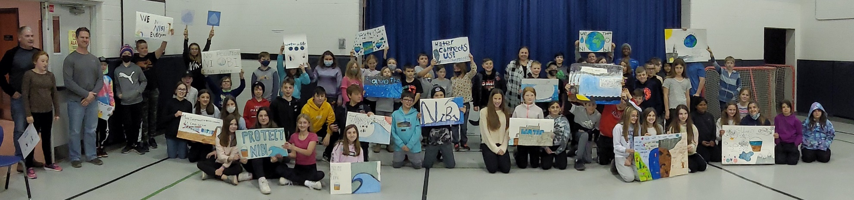

TRACK AND FIELD MEET
May 6th SPS will host its track meet at GFESS for students in Grades 4 – 8. Parents are welcome to come and watch. The rain date is May 12th.

WELCOME TO KINDERGARTEN

When: Thursday, May 12, 1:00 – 6:00 pm
Yes, it’s true! We can’t begin to explain how excited we are to welcome our newest little learners and their families back into our school, to come and see everything in person. We are looking forward to once again opening our school doors to your family for a very important visit.
On Thursday, May 12th, you, and your child can visit us any time between 1:00 – 6:00 pm to meet the Kindergarten team, take a peek at a Kindergarten classroom, and maybe even meet some future friends! You can visit www.dsbn.org/Kindergarten to learn more about Kindergarten at the DSBN or contact us at the school with any questions. We can’t wait to see you!
If you haven’t yet registered your K- child, please do so at www.dsbn.org/Kindergarten!
INTERMEDIATE TRIP

On Friday June 10th, Grade 7 and 8 students will be heading off to Cataract Bowling for a morning of fun, followed by a great lunch at The Mandarin to celebrate friendships made throughout their time at Stevensville. Details to follow.

GRADE 8 GRADUATION

Save the date for Friday June 24th! Details to follow in the next newsletter.

SCHOOL CARNIVAL
Bringing back an old tradition – school wide carnival on Tuesday June 28th! Details to follow and we will need parent volunteers.

PARENT COUNCIL
Please join us on the last Tuesday of the month at 6:15 pm. Each month a link will be sent to those who wish to participate via Teams. We will also have our first in-person meeting for those who wish to attend in person. Our meeting will take place in the library. Please email Geraldine.Davies@dsbn.org if you would like to join us on Tuesday May 24th!
Mental Health and Well – Being
Do you have questions about your child’s mental health and well-being? Did you know that students and families within the DSBN have access to a school-based social worker? Sarah Lichter is a DSBN Social Worker who is able to provide direct support to Stevensville students and families.
For more information about DSBN Social Work services please visit –
https://www.dsbn.org/programs-services/well-being/school-support
If you are seeking community-based well-being support, please visit –
https://www.dsbn.org/programs-services/well-being/community-support
Children and youth (and their families) can also access immediate mental health supports via –
- Pathstone Mental Health Crisis Support Line 1-800-263-4944 and Walk-In/Virtual Counselling Clinics https://pathstonementalhealth.ca/walk-in-clinic/
- Kids Help Phone 1-800-668-6868, or text CONNECT to 686868, or live chat at www.kidshelpphone.ca.
PUBLIC LIBRARY
Check out your local library for a comprehensive collection of books for all members of your family!
Click here to get your Fort Erie Public Library Card and please see the attachment from the Fort Erie Library
https://forterie.niagaraevergreen.ca/eg/opac/register

